**Task 01:**

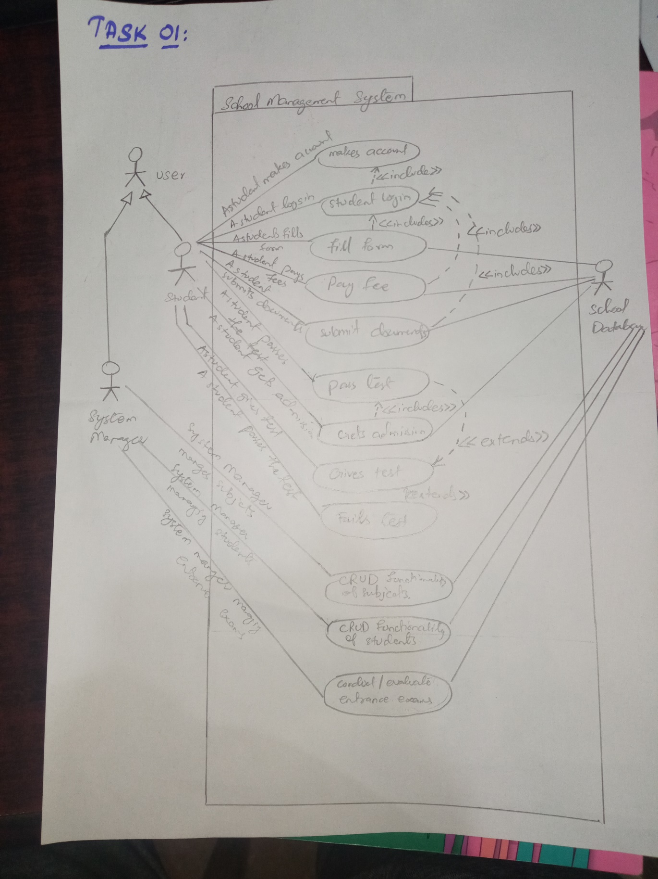

|  |  |
| --- | --- |
| ID: | UC 01 |
| Use case name: | Student Login |
| Author | Bilal Ahmed Khan |
| Last revision | 5/10/2022 |
| Description: | Student logs into the School Management system. |
| Primary Actor: | Student |
| Supporting Actor | Database system |
| Preconditions: | Student Log ins to the system |
| Postconditions: | Students submits his exam and views his result |
| Main  Success Scenario: | 1. A Student Logs in to the system. 2. He fills the registration form 3. He pays the fee 4. He submits the required documents 5. He gives the test 6. He gets admission if he passes the test. |
| Extensions: | 1. If the system crashes, Student restarts the System, logs in, and requests recovery of prior state. System reconstructs prior state. 2. Student enters wrong credentials   2a) Student is asked to enter correct email if the email is wrong  2b) Student is asked to enter correct password if the password is wrong   1. Student fails the test   3a) Student is asked to retake the test after 1 month   1. Students doesn’t pay the admission fee on time   4a) Student is asked to pay the admission fee so that his admission can be processed. |

|  |  |
| --- | --- |
| ID: | UC 02 |
| Use case name: | System Manager managing different aspects of the system |
| Author | Bilal Ahmed Khan |
| Last revision | 5/10/2022 |
| Description: | System Manager access the portal to add subjects (whole CRUD functionality), add students (whole CRUD functionality of students) and evaluate/conduct exams |
| Primary Actor: | System Manager |
| Supporting Actor | Database system, Student |
| Preconditions: | System Manager access the system |
| Postconditions: | System Manager has added new subjects/ modified existing subjects, he has added new students/modified existing students and conducted exams, evaluated exams. |
| Main  Success Scenario: | 1. Teacher accesses the system. 2. He adds new subjects, delete/update existing subjects 3. He adds news students, modifies attributes of existing students, deletes the record of students who have passed out. 4. He conducts exams (if any exams are due). 5. He evaluates exams (if any exams are up for devaluation). |
| Extensions: | 1. If the system crashes, System Manager restarts the System, logs in, and requests recovery of prior state. System reconstructs prior state. |

**Task 02**

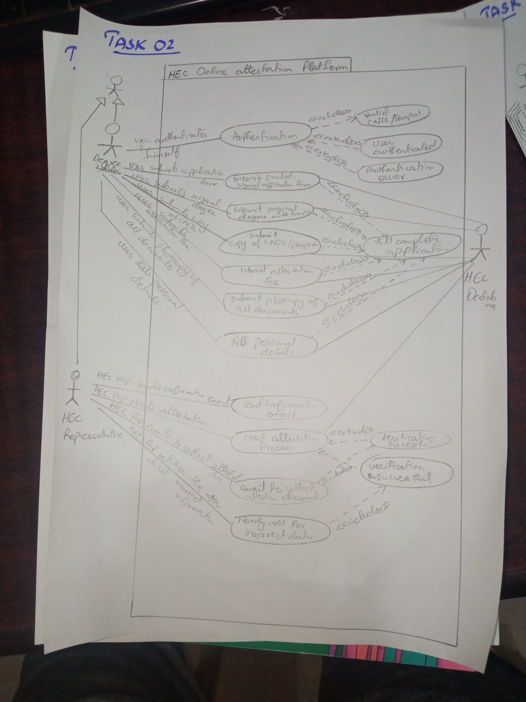

|  |  |
| --- | --- |
| ID: | UC 01 |
| Use case name: | Degree holder verification |
| Author | Bilal Ahmed Khan |
| Last revision | 5/10/2022 |
| Description: | Degree Holder enters his credential and documents into the system, after verification his documents are attested. |
| Primary Actor: | Degree Holder |
| Supporting Actor | HEC Representative |
| Preconditions: | Degree Holder is logged into system |
| Postconditions: | Degree Holder gets his documents verified |
| Main  Success Scenario: | 1. Degree holder authenticates himself via NIC/Passport verification 2. He submits his printed application form 3. Submits his original degree with transcript 4. Submits the attestation fee 5. Submits the photocopy of all documents 6. Fills his personal details |
| Extensions: | 1. Anytime the system crashes the user restarts they system and the system restores itself to its previous state 2. If the NIC/Passport is not valid user is prompted to enter a valid NIC/Passport number 3. User submits incomplete/incorrect documents/document details   3a) User is asked to enter correct and complete set of documents required for verification   1. User doesn’t submit fee   4a) User is asked to submit attestation fee to move forward with the verification process. |

|  |  |
| --- | --- |
| ID: | UC 02 |
| Use case name: | HEC Representative attesting documents |
| Author | Bilal Ahmed Khan |
| Last revision | 5/10/2022 |
| Description: | HEC Representative attesting the documents submitted by degree holder and doing their verification. |
| Primary Actor: | HEC Representative |
| Supporting Actor | Degree Holder, HEC Database |
| Preconditions: | Degree Holder has submitted his documents |
| Postconditions: | HEC Representative has attested the submitted documents and sent the confirmation email. |
| Main  Success Scenario: | 1. HEC Representative sends confirmation email of documents receival. 2. He starts the attestation process. 3. He emails the degree holder to collect the attested documents. |
| Extensions: | 1. Anytime the system crashes the user restarts they system and the system restores itself to its previous state 2. If the documents submitted are incorrect, the degree holder is asked to submit the documents.   2a) HEC representative sends email of unsuccessful verification process and further instructions |

**Task 03**

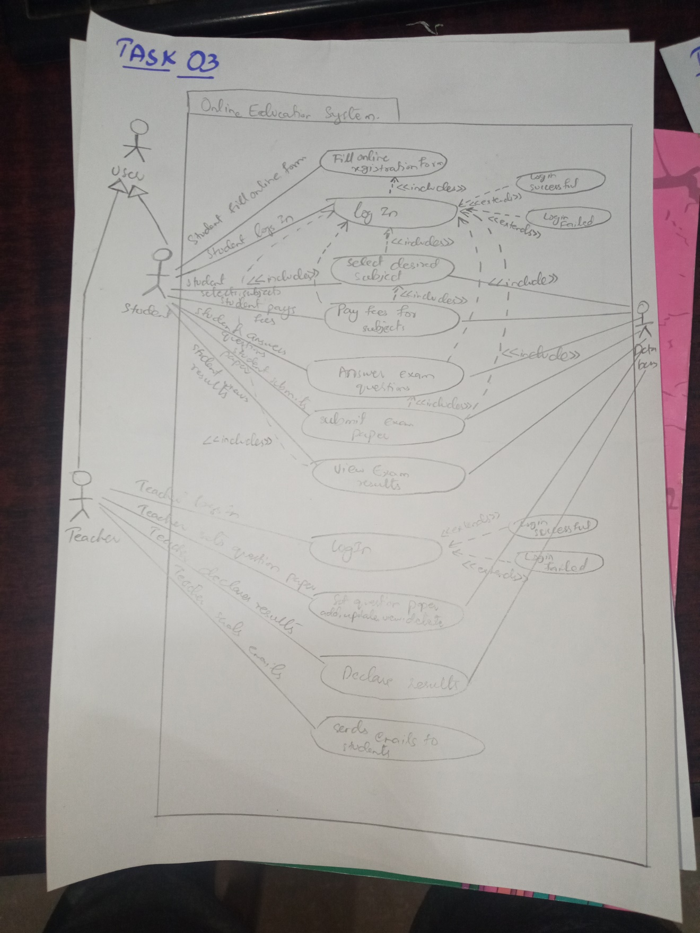

|  |  |
| --- | --- |
| ID: | UC-01 |
| Use case name: | Give online exam |
| Author | Bilal Ahmed Khan |
| Last revision | 5/10/2022 |
| Description: | Student logs into the system, gives his exam and views his result |
| Primary Actor: | Student |
| Supporting Actor | Teacher, database |
| Preconditions: | Student is logged into system |
| Postconditions: | Student views his result after giving the exam |
| Main  Success Scenario: | 1. Student logs in to the system 2. Student selects his desired subjects 3. Student pays the fee for his subject 4. Student attempts his exam and answers his questions 5. Student views his results |
| Extensions: | 1. At any time, System crashes: Student restarts the System, logs in, and requests recovery of prior state. System reconstructs prior state. 2. Student enters wrong log in credentials   2a) He is asked to enter correct password if the password is wrong, he is also given an option to recover his password via email, if he has forgotten his password  2b) He is asked to enter correct log in email if the email is wrong   1. Student hasn’t paid his fees on time   3a) Student is asked to pay his fee in order to appear in the exam |

|  |  |
| --- | --- |
| ID: | UC-02 |
| Use case name: | Check online exam |
| Author | Bilal Ahmed Khan |
| Last revision | 5/10/2022 |
| Description: | Teacher logs in to the system, set question paper, declare results and send results email to students. |
| Primary Actor: | Teacher |
| Supporting Actor | Student, database |
| Preconditions: | Teacher is logged in to the system. |
| Postconditions: | Teacher has set the question paper, announced results and sent result emails to students. |
| Main  Success Scenario: | 1. Teacher logs in to the system. 2. Teacher sets the question paper. 3. Teacher announces the results. 4. Teacher send confirmation emails to the students. |
| Extensions: | 1. At any time, System crashes: Teacher restarts the System, logs in, and requests recovery of prior state. System reconstructs prior state. 2. Teacher enters wrong log in credentials   2a) He is asked to enter correct password if the password is wrong, he is also given an option to recover his password via email, if he has forgotten his password  2b) He is asked to enter correct log in email if the email is wrong |

**Task 04**

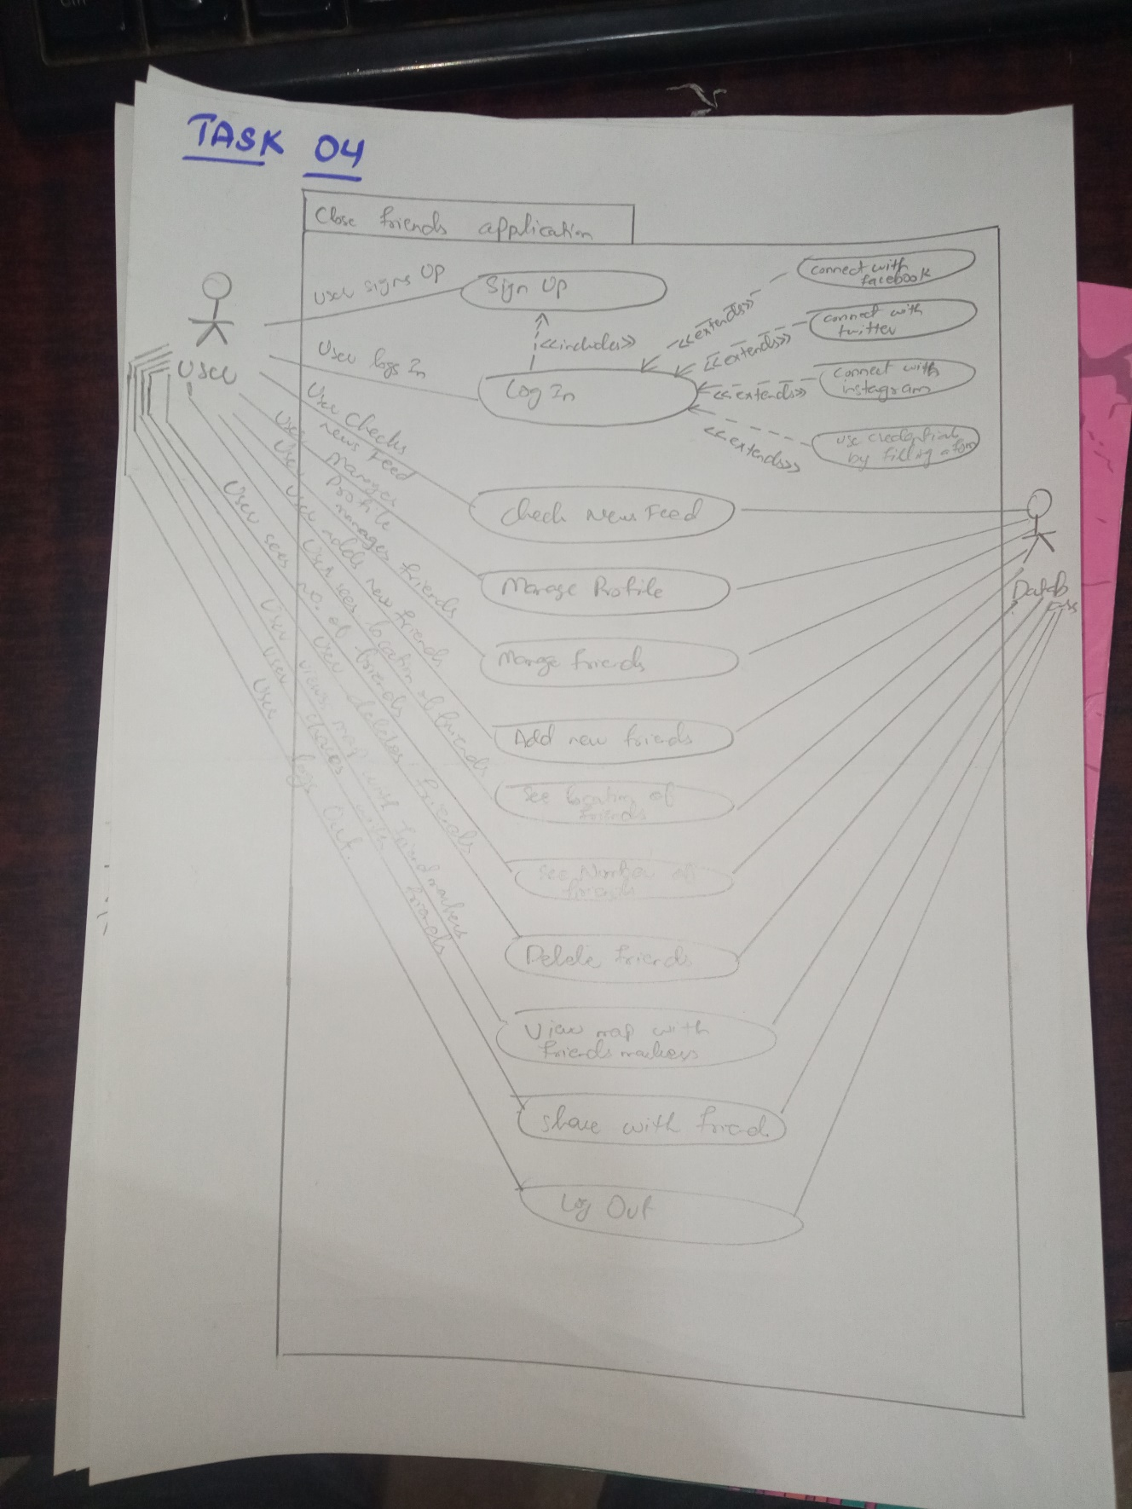

|  |  |
| --- | --- |
| ID: | UC 01 |
| Use case name: | Log in and use close friends application |
| Author | Bilal Ahmed Khan |
| Last revision | 5/10/2022 |
| Description: | User logs into the app and uses it to interact with his existing friends and make new friends. |
| Primary Actor: | User |
| Supporting Actor | Database system |
| Preconditions: | User has logged into system |
| Postconditions: | User has logged out of the app after using the app |
| Main  Success Scenario: | 1. User logs into the app 2. User makes new friends on the app 3. User views his new feed 4. User check his current friend’s activity 5. User logs out of the app after using it for some time |
| Extensions: | 1. At any time, System crashes: Student restarts the System, logs in, and requests recovery of prior state. System reconstructs prior state. 2. User enters wrong log in credentials   2a) User is asked to enter correct email if he enters the wrong log in email  2b) User is asked to enter the correct password if he enters the wrong password and also given the option to retrieve his password using his email. |